7. Gridded Image Acquisition (Standalone Micro-Manager)

As of April 2017, images have been acquired via Micro-Manager software, which has the ability to interface with Matlab in addition to being standalone imaging control software. It is known to be buggy.

NOTE: You MUST be trained by a qualified user of the microscopes before use

Gridded Acquisition

- Find the exposures for the channels and objective of interest:
  - Set binning (2x2 for medium size and decent resolution)
  - Focus image, turn off lights and turn off Perfect Focus
  - Find an exposure time with strong signal and no saturation
- Click the Multi-D. Acq. button to open the following window:

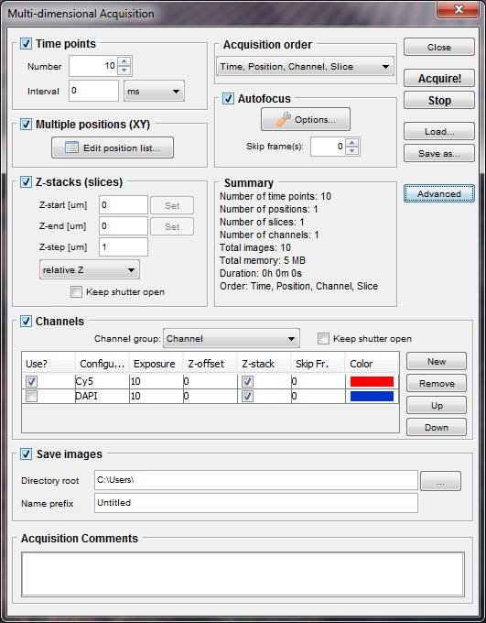
- Check the Multiple Positions and the Channels boxes and apply the appropriate exposures found in (1) for the desired channels
- Click the “Edit position list” button and “Create Grid” in the popup window to define the area to be imaged
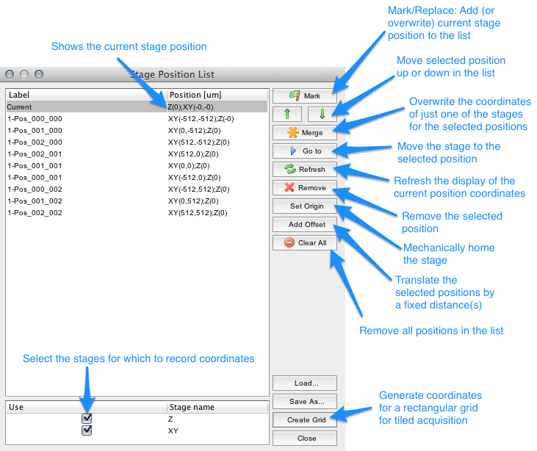

- In Live View, center the objective on the corners of the array to be imaged and “Set” the coordinates in the popup window so they correspond with the physical location of the array on the stage. Set overlap to 20% and accept the settings. Ignore "Center Here".
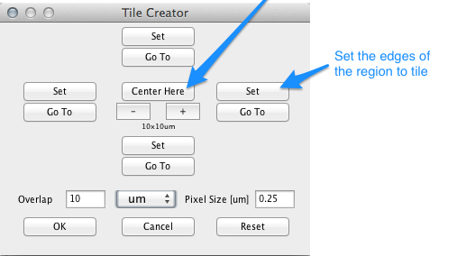
- Return to the Mutli-D Acq window , check the Save Files box and set the folder and file name (saving as a stacked TIFF) and then hit the “Acquire!” button
Micro-Manager Suggestions

- If not using automated image acquisition, it is often most convenient to not save images to disk and let them float in RAM until the acquisition has been completed. If Micro-Manager freezes during an acquisition where images are saved to disk, some data folders will contain an incomplete dataset
- If capturing multiple image sets of the same microfluidic device, it is often most convenient to save the coordinates with the "Save As" button on the "Stage Position List" window. If Micro-Manager freezes during an acquisition, restart Micro-Manager or PC and load in the coordinates file to maintain identical coordinates
- Always save as a stacked TIFF

Micro-Manager Troubleshooting

Issue: Micromanager freezes
Solution:
- Force quit Micromanager
- Power cycle the Andor camera
- Reboot Micromanager
Issue: Micromanager freezes repetitively and the solution above doesn’t fix it
Issue: Micromanager doesn’t update its current settings when changed
Solution:
- Restart the computer
- Power cycle the Andor camera, Nikon and ASI stage
- Log back in
- Reboot Micromanger

